[The truths below are rather badly tangled up with the 2016 election politics. You can confirm whatever bias you bring to this. –FNC]

This document is in three parts.

[Go to the profile of Weird History](https://medium.com/@editors_91459?source=post_header_lockup)

[Weird History](https://medium.com/@editors_91459?source=post_header_lockup) Follow

History is weird. A lot weirder than you think. Follow us on Facebook: http://bit.ly/2GRzK4L

Mar 27 [Year unspecified, 2018 probably.]

1. **Trump’s Dad Was So Racist, Woody Guthrie Wrote A Song About It**

In 1950, Woody Guthrie signed a lease for an apartment in Brooklyn; his landlord was Fred C. Trump

This first part is from:: <https://medium.com/@editors_91459/trumps-dad-was-so-racist-woody-guthrie-wrote-a-song-about-it-deea588fa11a>

*By*[*Mariel Loveland*](https://business.facebook.com/rankerweirdhistory/)

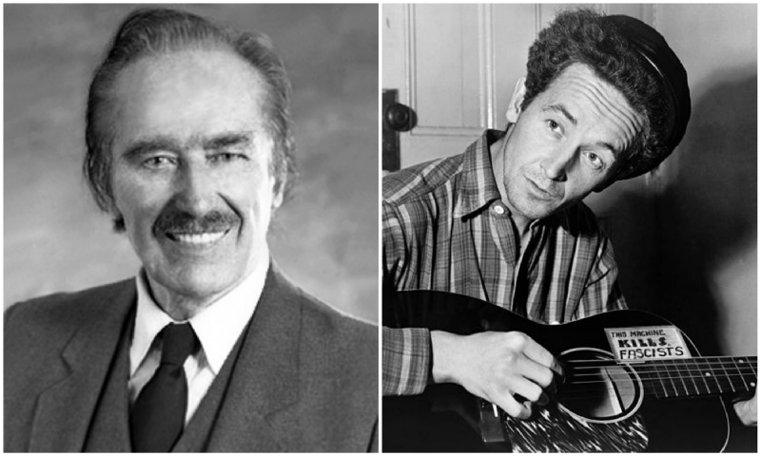

Source: [Wikimedia Commons](https://en.wikipedia.org/wiki/File:Fred_Trump.png)/[Wikimedia Commons](https://commons.wikimedia.org/wiki/File:Woody_Guthrie_2.jpg)

In 2015, future President Donald Trump issued a seemingly innocuous — but increasingly portentous when put into context — statement: “My legacy has roots in my father’s legacy.” But it might be more than business acumen that has trickled down from the top of the gold-encrusted Trump family tree. Trump’s dad Fred had an unexpected occupant in one of his New York properties in the early 1950s: American singer-songwriter and social justice warrior Woody Guthrie. And guess what? Guthrie was no fan of “Old Man Trump.”

While contemporary musicians like Adele, Miley Cyrus, and Waka Flocka Flame have all taken to social media in order to criticize Donald Trump’s ideals, this was merely round two of musicians coming for the Trumps. Over 60 years ago, Guthrie was feverishly penning tunes lambasting Fred Trump for racist behavior. “Old Man Trump,” Guthrie’s song about Fred, exposed a dark world where the landlord and rumored [KKK affiliate](http://www.ranker.com/list/fred-trump-arrested-kkk-rally/amandasedlakhevener) profited from an apartment complex that housed only white families. It included the scathing lines, “I suppose that Old Man Trump knows just how much racial hate/He stirred up in that bloodpot of human hearts/When he drawed that color line.”

**Guthrie was no stranger to American protest songs by the time he was spitting fire about Fred Trump**

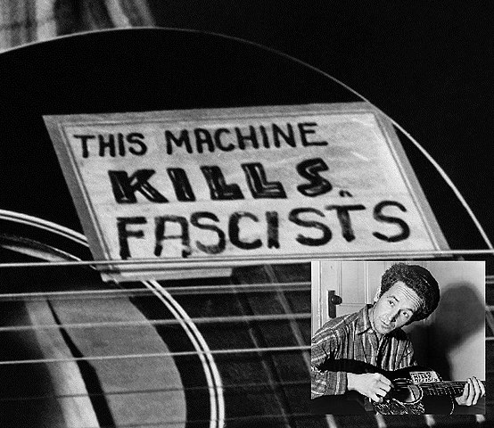

Source: [Wikimedia Commons](https://commons.wikimedia.org/wiki/File:Guthrie_guitar_this_machine_kills_fascists.jpg)

Woodrow Wilson, “Woody,” Guthrie is regarded as a founding father of American protest music. His most famous work was an [alternative version](http://www.npr.org/2000/07/03/1076186/this-land-is-your-land) of “God Bless America” — “This Land Is Your Land,” which he penned in 1940, recorded in 1944, and released in 1951. In the decades since its inception, the tune has been played at protest rallies, sung around campfires, and trumpeted at progressive schools because of its appeal to a Left-leaning political mentality. Guthrie’s upbringing and lifestyle allowed him to understand struggle within the tight confines of the American dream. He was thrown deep into the trenches of American life as he walked, hitchhiked, and road railways from his home in Oklahoma across the country.

[By the time Guthrie encountered Fred Trump](http://www.huffingtonpost.com/entry/woody-guthrie-trump_us_56a18e5ae4b0404eb8f11bb3), he had already written racially charged protest songs like “The Ferguson Brothers Killing,” which condemned the police brutality that killed Charles and Alfonso Ferguson in 1946. However, it took over 60 years for historians to discover the impact Fred Trump had on the singer-songwriter.

**Before the two tangled, Fred Trump had already been arrested at a KKK rally**

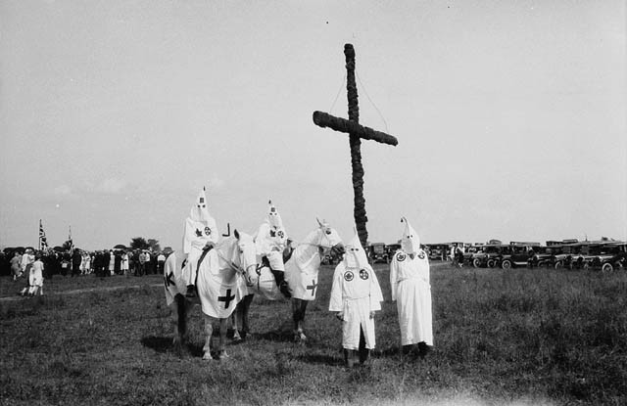

Source: [Wikimedia Commons](https://commons.wikimedia.org/wiki/File:Ku_Klux_Klan_at_a_gathering_near_Kingston,_Ontario_in_1927.jpg)

In May of 1927, a 21-year-old Fred Trump was arrested in the melee surrounding a Klan rally in Jamaica, Queens. A [*New York Times*](http://boingboing.net/2015/09/09/1927-news-report-donald-trump.html) article from the incident describes the scene as “1,000 Klansmen and 100 policemen [staging] a free-for-all.” For his part, Donald Trump vehemently denied that his father was ever arrested at a Klan rally, and he urged [*New York Times*](https://www.nytimes.com/politics/first-draft/2015/09/22/in-interview-donald-trump-denies-report-of-fathers-arrest-in-1927/)reporter Jason Horowitz to drop the subject in an interview, stating, “It shouldn’t be written because it never happened, number one. And number two, there was nobody charged.”

Trump did get one thing right: his father was never charged. Out of the seven people arrested, Trump’s father was the only one who got off completely free. According to a clipping from the now defunct *Daily Star*, four of those arrested were expected to go to court, and two were paroled. One, Fred Trump, was not held on charges. However, this doesn’t negate his standing as a member of the Klan. According to newspaper clip obtained by [VICE](https://www.vice.com/en_us/article/mvke38/all-the-evidence-we-could-find-about-fred-trumps-alleged-involvement-with-the-kkk), all the people arrested were wearing Klan attire, which VICE contends likely would have included Fred Trump.

**Decades after the Klan rally, Fred Trump became a real estate mogul**

The years following Fred Trump’s arrest were very fruitful for the budding real estate mogul. He became a wealthy real estate developer who housed thousands of families in New York while fielding consistent [accusations of racism](https://www.vice.com/en_us/article/mvke38/all-the-evidence-we-could-find-about-fred-trumps-alleged-involvement-with-the-kkk). Some of the complaints were informal, and some were blasted out through the power of song. The “informal” accusations came to a head when Woody Guthrie accused Trump of drawing a “color line” in a neighborhood near Coney Island. The formal accusations reached a peak in the 1970s, when the US Department of Justice brought a claim against Trump and his son, Donald, for racist housing practices.

**Fred Trump developed the Beach Haven public housing complex as part of the postwar affordable housing boom**

In the years following World War II, hundreds of thousands of servicemen returned to New York City, and affordable public housing became a major priority for local government. The [Federal Housing Authority](https://www.theguardian.com/music/2016/jan/22/woody-guthrie-donald-trump-real-estate-empire-racist-foundations) stepped in to issue loans and subsidies for developers willing to construct blocks of housing. Guess who jumped at the opportunity? Fred Trump. Trump ended up making much of his fortune by constructing public housing and collecting rent on the properties.

**In December 1950, Woody Guthrie signed a lease at Beach Haven**

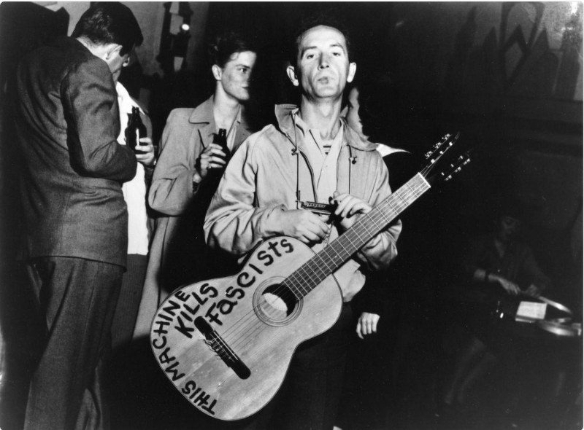

Source: Photo: Studio420/[Twitter](https://twitter.com/Studio420Ben/status/897284849765142528)

When Guthrie signed a two-year lease at Trump’s Beach Haven property in 1950, he started noticing that nearly all of the families who lived in the complex were white. [Will Kaufman](https://theconversation.com/woody-guthrie-old-man-trump-and-a-real-estate-empires-racist-foundations-53026), who uncovered Guthrie’s notes about the period while doing research in the Woody Guthrie Center’s archives, writes that the singer-songwriter was, “lamenting the bigotry that pervaded his new, lily-white neighborhood” when he penned the song “Old Man Trump.”

Guthrie’s lyrics went as follows:

I suppose  
Old Man Trump knows  
Just how much  
Racial Hate  
he stirred up  
In the bloodpot of human hearts  
When he drawed  
That color line  
Here at his  
Eighteen hundred family project.

**What Guthrie didn’t know was that the FHA had specific racial guidelines**

Fred Trump wasn’t acting on his own when he refused to rent property to people of color. In the 1950s, the FHA, which fronted the bill for some of Trump’s housing projects, had a set of guidelines for avoiding “inharmonious uses of housing.” According to Trump biographer [Gwenda Blair](http://www.simonandschuster.com/books/The-Trumps/Gwenda-Blair/9780743210799), this was, “[a code phrase for selling homes in white areas to blacks](https://www.theguardian.com/music/2016/jan/22/woody-guthrie-donald-trump-real-estate-empire-racist-foundations).” The practice of refusing to rent people of color homes in traditionally white areas was rather common among FHA projects. It only took a year for Guthrie to find out the truth.

**Guthrie imagined a world where he could transform Trump’s complex into a racially diverse community**

In the year he lived there, Guthrie dubbed Beach Haven “Bitch Haven.” His notebooks from the period, which outline the lyrics to “Old Man Trump,” imagine a world where he could break the cycle of racism. He [wrote](https://www.theguardian.com/music/2016/jan/22/woody-guthrie-donald-trump-real-estate-empire-racist-foundations):

I welcome you here to live. I welcome you and your man both here to Beach Haven to love in any ways you please and to have some kind of a decent place to get pregnant in and to have your kids raised up in. I’m yelling out my own welcome to you. [This is a reference to the Guardian article dated Fri 22 Jan 2016 11.09 EST. –FNC]

**Woody Guthrie hated Fred Trump so much, he also reworked an old song to be about him**

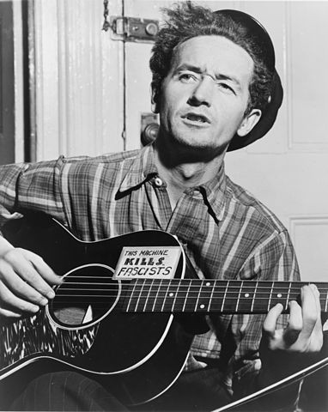

Source: [Wikimedia Commons](https://commons.wikimedia.org/wiki/File:Woody_Guthrie_NYWTS.jpg)

Woody Guthrie didn’t just write “Old Man Trump” about Fred Trump’s alleged racism. He also reworked his song “Ain’t Got No Home” to be about the moral struggle of living in an affordable housing complex where black citizens aren’t allowed.

According to [Professor Will Kaufman](http://www.nytimes.com/politics/first-draft/2016/01/25/woody-guthrie-sang-of-his-contempt-for-his-landlord-donald-trumps-father/), his new lyrics read:

Beach Haven ain’t my home!  
I just can’t pay this rent!  
My money’s down the drain!  
And my soul is badly bent!  
Beach Haven looks like heaven  
Where no black ones come to roam!  
No, no, no! Old Man Trump!  
Old Beach Haven ain’t my home!

**Fred Trump faced formal charges of discrimination in 1973 and 1978**

Though Guthrie caught on quickly and moved out of Beach Have within two years, it took substantially longer for [actual discrimination cases](https://www.villagevoice.com/2015/07/20/how-a-young-donald-trump-forced-his-way-from-avenue-z-to-manhattan/) to be brought against Trump. In 1973 and 1978, the Civil Rights Division of the US Justice Department leveled accusations against the Trump family, including the major charge of “racially discriminatory conduct by Trump agents.” The worst evidence came from his own employees.

According to court records, four superintendents and rental agents confirmed that housing applications were coded by race, and doormen were told to discourage black apartment-seekers from entering the building by claiming there were no vacancies or falsely hiking up rents. One superintendent claimed he was told to send black applicants to the central office, while white applicants could be dealt with on site. Another rental agent claimed that Trump directly told her not to rent to blacks.

In 1983, the New York State Division of Housing and Community Renewal looked at Fred Trump’s properties again, mainly “Trump Village” residential properties. They found that residents were [95% white](http://www.nytimes.com/1983/10/16/realestate/for-starrett-city-an-integration-test.html?scp=4&sq=trump+discrimination&st=nyt&pagewanted=all).

**“Old Man Trump” was recorded and released in 2016**

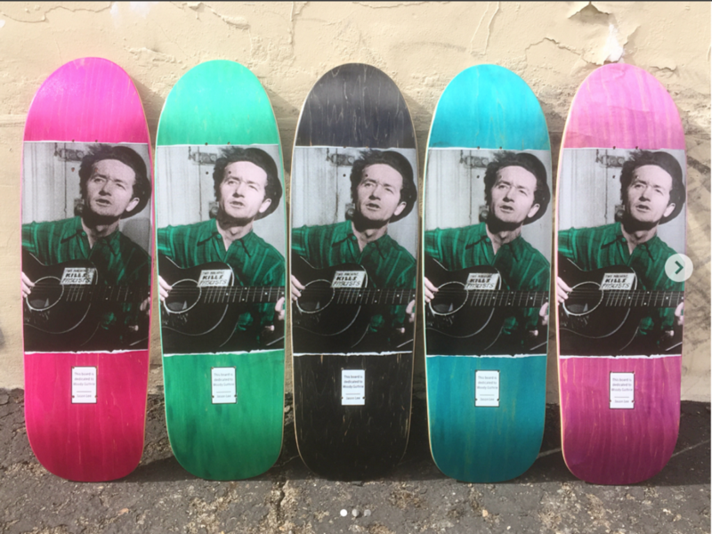

Source: [socalskateshop/Instagram](https://www.instagram.com/p/BgUiqrajkbd/?tagged=woodyguthrie" \t "_blank)

Guthrie’s song “Old Man Trump” was nearly lost until it was uncovered right before Donald Trump hit the campaign trail in 2016. Three artists collaborated to finish and produce Guthrie’s batch of lyrics — folk singers Ryan Harvey and Ani DiFranco, and guitarist Tom Morello. It was released by Firebrand records months after the lyrics were discovered. Harvey [said](https://www.theguardian.com/music/2016/jun/30/old-man-trump-tom-morello-ani-difranco-woody-guthrie):

You’ve got Donald Trump talking about making America great again… and so here’s Woody Guthrie, one of the definers of American history, coming out after his death and saying ‘No, it wasn’t a great era and in fact your father was part of the problem.’ This is a modern song that just happened to be written in the past.

[Go to the profile of Weird History](https://medium.com/@editors_91459?source=footer_card)

[**Weird History**](https://medium.com/@editors_91459)

History is weird. A lot weirder than you think. Follow us on Facebook: <http://bit.ly/2GRzK4L>

This document is in three parts.

# II. Old Man Trump: Tom Morello gives new life to Woody Guthrie's protest song

This third part is from: <https://www.theguardian.com/music/2016/jun/30/old-man-trump-tom-morello-ani-difranco-woody-guthrie>

Three artists are finishing and producing Guthrie’s song criticizing Donald Trump’s father and reflecting on race – a very current topic in his campaign

Ciara McCarthy in New York

@mccarthy\_ciara

Thu 30 Jun 2016 14.36 EDT Last modified on Fri 9 Feb 2018 14.10 EST

This article is over 2 years old

Shares

2,012

Comments: 31 [Some worth reading. –FNC]

Image of Woody Guthrie Here.

Guthrie penned Old Man Trump at a time when he was thinking deeply about race and segregation in the US. Photograph: Eric Schaal/Time & Life Pictures/Getty Image

More than 60 years ago, Woody Guthrie bemoaned his landlord – Donald Trump’s father, Fred Trump – in unrecorded song lyrics. Now a group of artists has turned his writing into a modern protest song as Trump’s son Donald continues his candidacy for US president.

Three artists have collaborated to finish and produce Old Man Trump, Guthrie’s song inspired by Fred Trump. The track, which had never been previously recorded, was released last week by Firebrand Records just months after the lyrics were re-discovered and publicized. Old Man Trump was recorded by riot folk singer Ryan Harvey with Ani DiFranco and guitarist Tom Morello.

“You’ve got Donald Trump talking about making America great again ... and so here’s Woody Guthrie, one of the definers of American history, coming out after his death and saying ‘No, it wasn’t a great era and in fact your father was part of the problem,’ ” Harvey said.

Guthrie, a pillar of American protest music most famous for the alternative national anthem This Land Is Your Land, signed his Brooklyn lease with Trump senior as his landlord in 1950. The real estate developer inspired song lyrics and other writings, whose existence and relevance remained forgotten until recently.

In January, Will Kaufman, a Guthrie expert and professor at the University of Central Lancashire, brought to light Guthrie’s impassioned writings about Trump. Kaufman said he found the Guthrie’s writings before Donald Trump had announced his candidacy while doing research for an upcoming book about Guthrie. After Kaufman re-publicized Guthrie’s writings, Harvey began looking to record the song for the first time because of the lyrics’ enduring relevance, he said.

“It’s about how stuff was racist in the 50s and how stuff is racist now,” Harvey said of the song. “This is a modern song that just happened to be written in the past.” Harvey found enthusiastic collaborators looking to stand against the “politics of hate”.

In a video introduction to the song, guitarist Morello implores listeners to “stand up” against Trump.

“When it comes to race relations, he’s like an old-school segregationist. When it comes to foreign policy, he’s like an old-school napalmist. When it comes to women’s issues, he’s like a frat-house rapist,” Morello says in the video. “So let’s not elect that guy.”

The elder Trump was Guthrie’s landlord for two years in the 1950s. The public housing complex, named Beach Haven, was built near Coney Island and almost exclusively housed white tenants. (Kaufman described the neighborhood as “lily-white”.) Trump, who built Beach Haven using federal loans, made significant profits from the project.

In 1954, after Guthrie had already moved out, Trump was the subject of a federal investigation for overstating the cost of developing Beach Haven and pocketing the $3.7m difference. A Village Voice investigative series published in 1979 looked at the Trumps’ real estate empire, including the cases brought by the US justice department alleging “racially discriminatory conduct by Trump agents”.

Guthrie’s writings focus in particular on the racial segregation within the housing complex: “I suppose/Old Man Trump knows/Just how much/Racial Hate/he stirred up/In the bloodpot of human hearts/When he drawed/That color line/Here at his/1800 family project”.

Guthrie penned Old Man Trump at a time when he was thinking deeply about race and segregation in the US, Kaufman said. In a letter to his friend activist Stetson Kennedy, Guthrie described the Beach Haven complex as a “JimCrow [sic] town”.

“His landlord Fred Trump is in essence the mayor of ‘JimCrow town’, this segregated town,” Kaufman explained. Guthrie lived in Beach Haven for two years until his wife broke the lease with Trump when Guthrie became increasingly ill after being diagnosed with Huntington’s disease. Kaufman said he returned to Guthrie’s writings on Fred Trump as Donald Trump began to discuss race on the campaign trail. Trump has proposed banning all Muslims from the US and said an Indiana-born federal judge was biased because of his Mexican heritage.

“I think it is really important that Woody is speaking to us from beyond the grave now,” Kaufman said.

Comments: 31 [Some worth reading. –FNC]

This document is in three parts.

# Woody Guthrie -- I Ain't Got No Home/Old Man Trump by the Missin' Cousins

From: <https://www.youtube.com/watch?v=jANuVKeYezs>

243,590 views

[The Missin' Cousins](https://www.youtube.com/channel/UCW4tMxOMV6TyZwXal0cD5Pg)

Published on May 8, 2016

SUBSCRIBE 327

In December 1950, Woody Guthrie moved to an apartment building in Brooklyn – Beach Haven Apartments. His landlord: Fred Trump, father of Donald Trump. Woody Guthrie wrote these lyrics in 1951, and 65 years later, the Missin' Cousins, a County-Western music group from Oakland California, present a recording of these new lyrics to I Ain't Got No Home in this World Anymore. (Here's our follow up [not the above] Woody Guthrie song: All You Fascists Bound to Lose -- [https://www.youtube.com/watch?v=ahl7\_...](https://www.youtube.com/watch?v=ahl7_kCIiAk) ) To read the fascinating story about where these lost Woody Guthrie lyrics about Old Man Trump came from, see this article by Woody Guthrie scholar professor Will Kaufman: [https://theconversation.com/woody-gut...](https://www.youtube.com/redirect?redir_token=PhxxX1iJBB-La01xzfDonpCE5Fd8MTUzOTEyNjEwMEAxNTM5MDM5NzAw&q=https%3A%2F%2Ftheconversation.com%2Fwoody-guthrie-old-man-trump-and-a-real-estate-empires-racist-foundations-53026&v=jANuVKeYezs&event=video_description) I suppose Old Man Trump knows Just how much Racial Hate he stirred up In the bloodpot of human hearts When he drawed That color line Here at his Eighteen hundred family project .... Fred Trump used US government millions to build post-war public housing, then became the landlord, and moved people of color out of their housing and neighborhoods. He kept people of color out of of his properties through racial codes, maintaining whites only housing policy into the early 1970's. Old Man Trump made his millions creating the postwar racial codes that have produced the racist inequality that lives through this day. In his two years at Beach Haven, Woody Guthrie witnessed Old Man Trump’s racist practices, and wrote some of his most bitter songs and lyrics, including a re-write of "I Ain't Got No Home in this World Anymore" aimed directly at Old Man Trump: Beach Haven ain't my home! I just cain't pay this rent! My money's down the drain! And my soul is badly bent! Beach Haven looks like heaven Where no black ones come to roam! No, no, no! Old Man Trump! Old Beach Haven ain't my home! For more Missin' Cousins music see: [https://themissincousins.bandcamp.com/](https://www.youtube.com/redirect?redir_token=PhxxX1iJBB-La01xzfDonpCE5Fd8MTUzOTEyNjEwMEAxNTM5MDM5NzAw&q=https%3A%2F%2Fthemissincousins.bandcamp.com%2F&v=jANuVKeYezs&event=video_description) p.s. we disabled the comments for this song because this trump shit is just too depressing. “Beach Haven Race Hate,” “Beach Haven Ain’t My Home” 1952, by Woody Guthrie, © copyright Woody Guthrie Publications, Inc